Protez Ayaklar

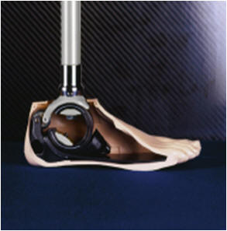 |  | 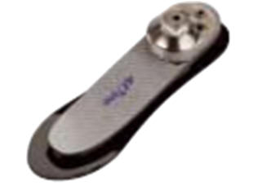 |  | 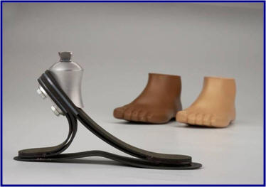 |  | 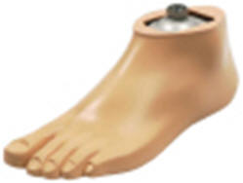
1C40 C-Walk Ayak |  | 1E56 Axtion Ayak |  | 1C30 Trias Ayak |  | 1D35 Dinamik Plus Ayak
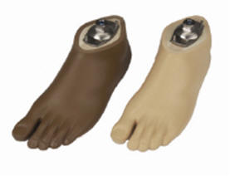 |  | 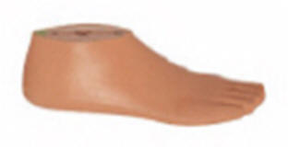 |  | 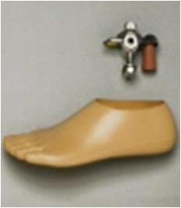 |  | 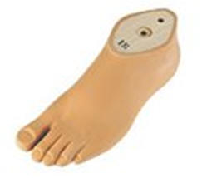
1D10 Dinamik Ayak |  | 1S66 Sach Ayak |  | 1H38 - 1 H40 Mafsall Ayak |  | 1G6 Hafif Ayak
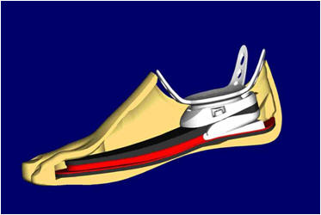 |  | 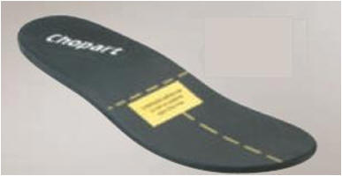 |  | 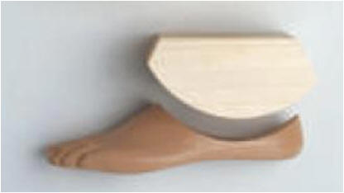
1C20 = * Prosymes |  | 1E80 = * Springlite Chopart Ayak |  | 1P9 =* Prigoff Ayak

